Lateral movement schedule task case:

1.Science it is related to scheduled task search of the keyword scheduled task.
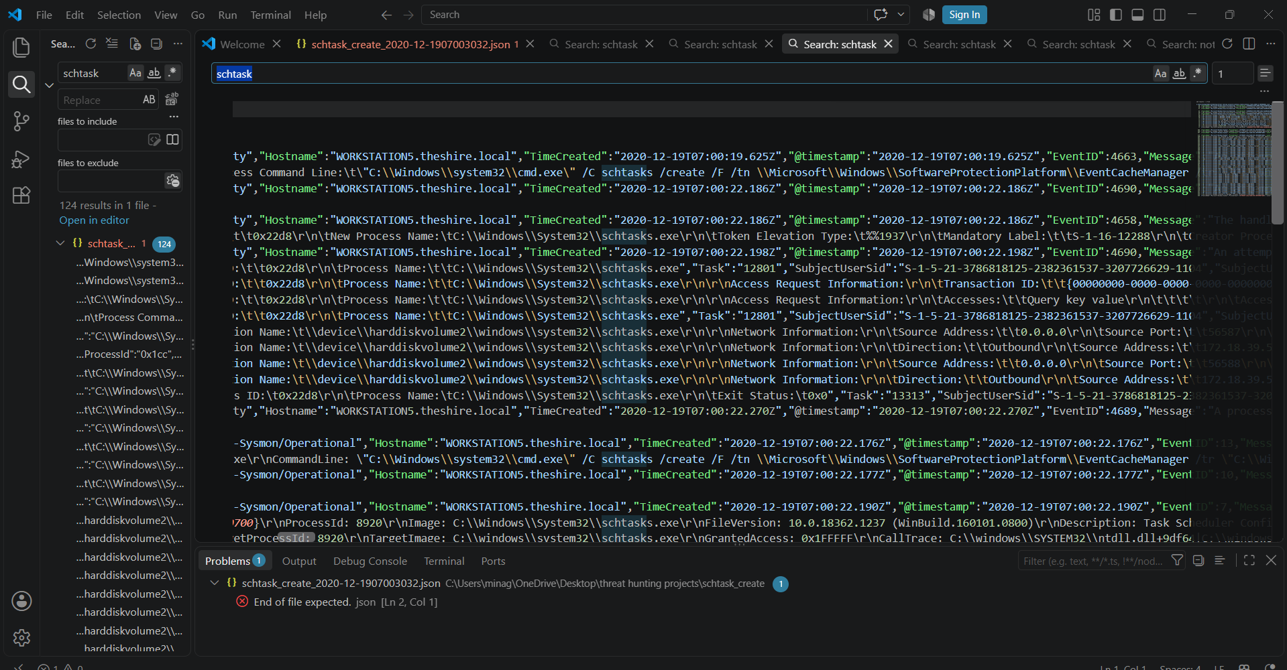
2.Observed schedultash is cread for cmd.exe executing the notepad.exe Process Command Line:\t\"C:\\Windows\\system32\\cmd.exe\" /C schtasks /create /F /tn \\Microsoft\\Windows\\SoftwareProtectionPlatform\\EventCacheManager /tr \"C:\\Windows\\system32\\cmd.exe /C C:\\Windows\\System32\\notepad.exe\" /sc ONSTART /ru system /S
Search for message it give description what had happened
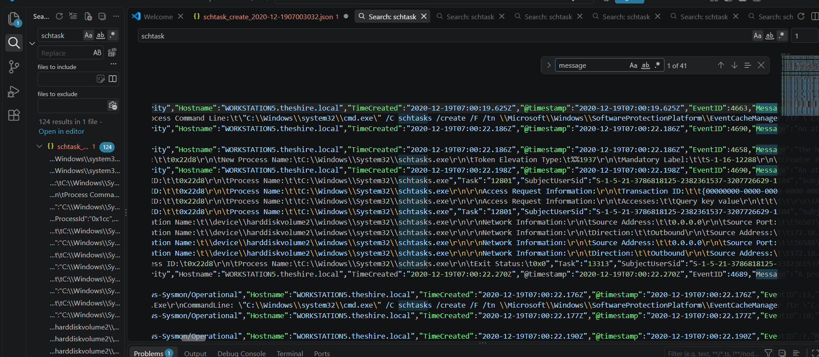
The message indicates the handle was accessed duplicated
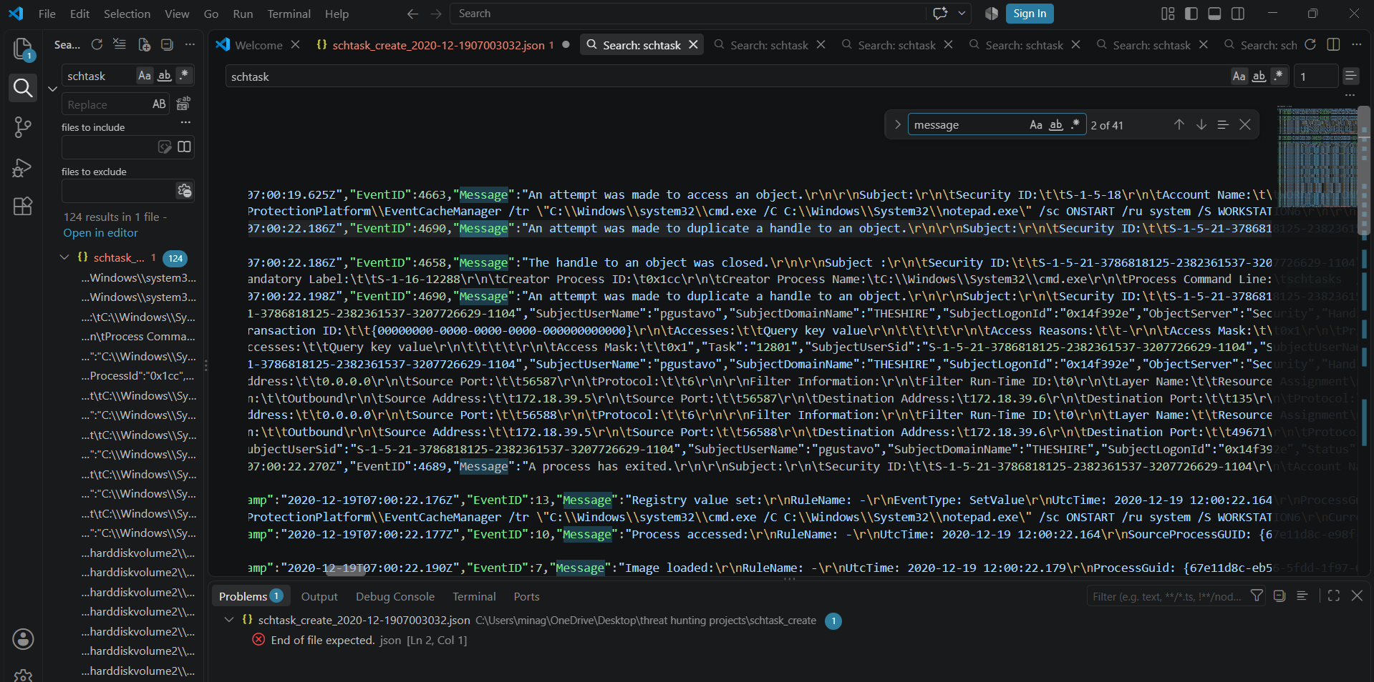
The message indicates there is connection
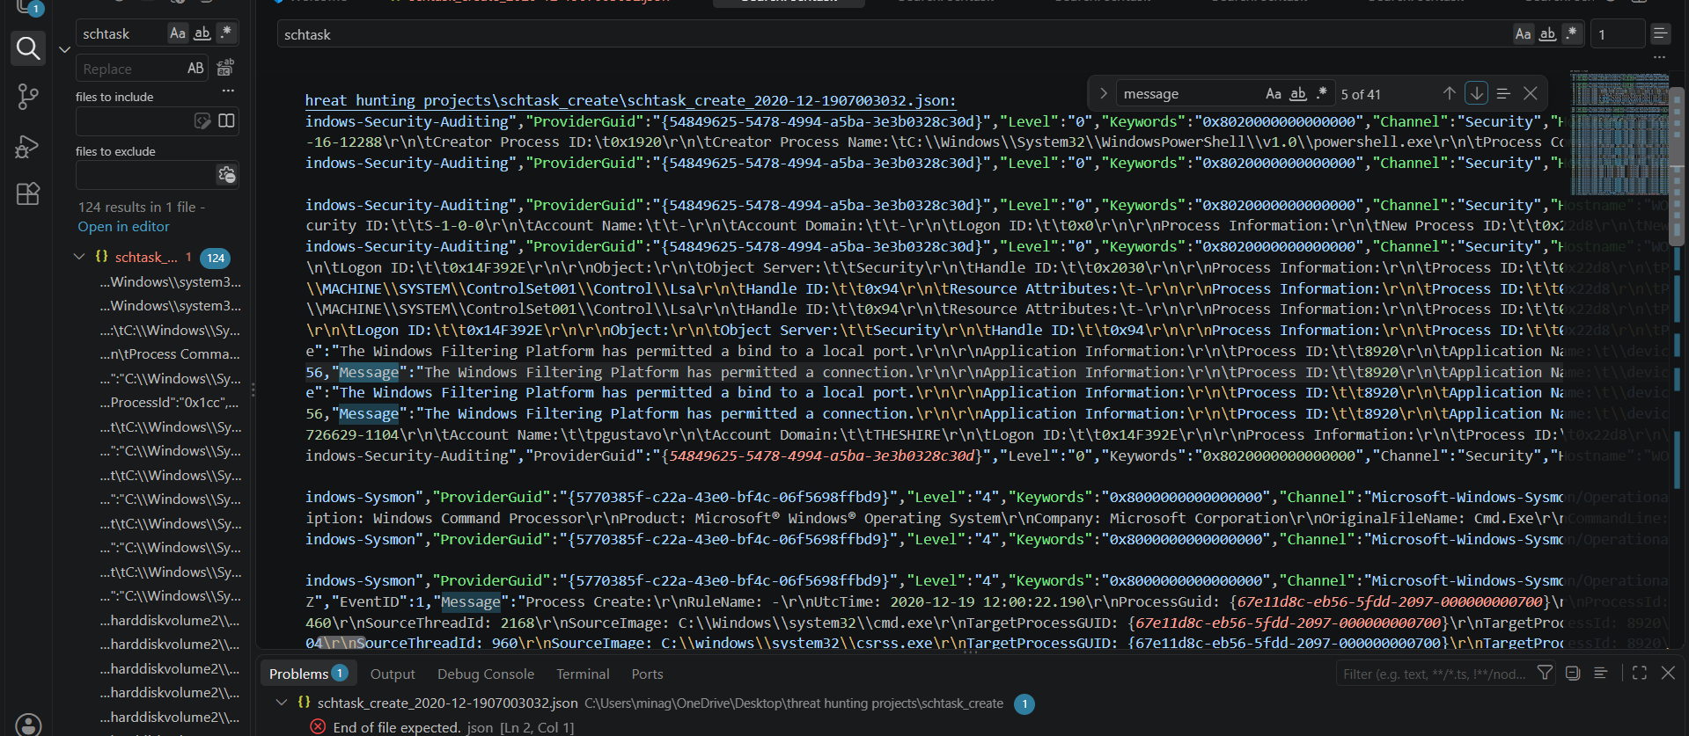
The message indicates libraries are loaded
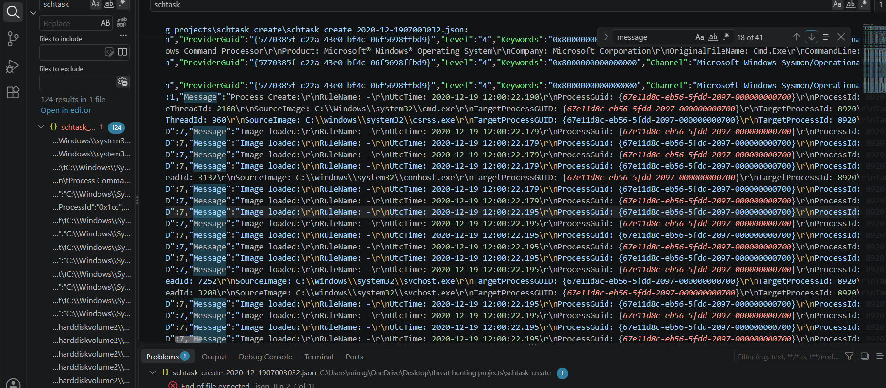
Search for objects here it is service sysmondrv
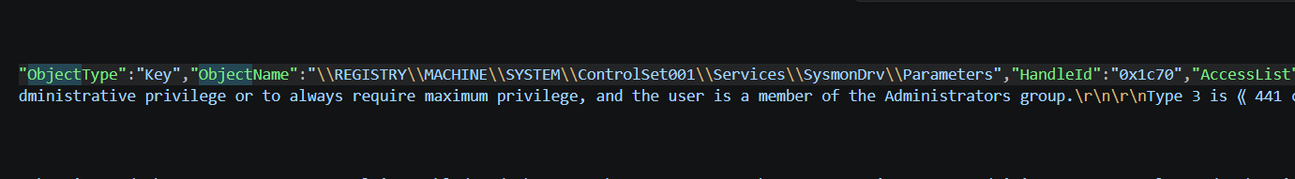
Here the object is lsa
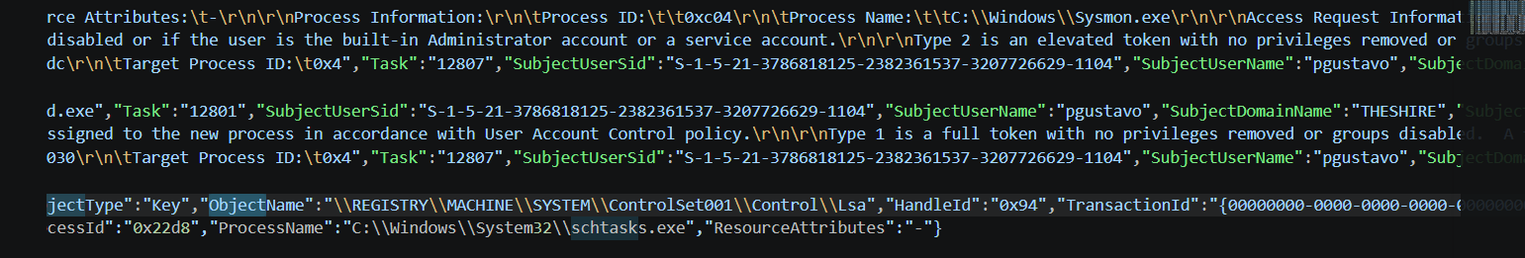
Here the object id service tcpip
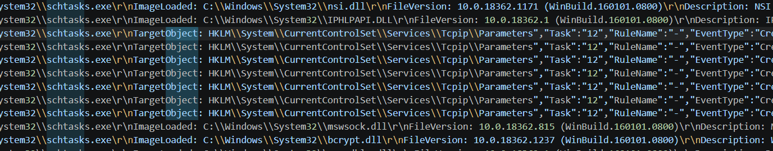
The message was connect search for source ip port which are 172.16.39.5 and destination ip 172.16.39.6 ports are 135,49671
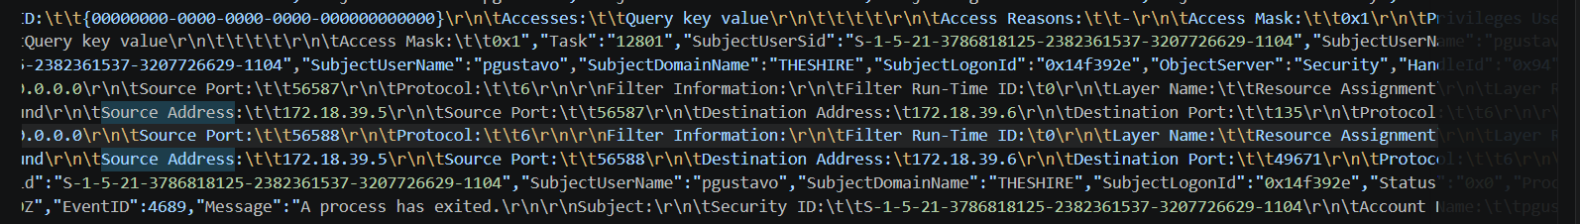
Overall activity:
The scheduled task is created for cmd.exe executing the notepad.exe. additionally observed there was a connection in between the destination is same network as source and destination ports are 135(remote procedure call port), 49671 . So based on this there is also possible lateral movement.

